TITLE : RS232 Monitor

LECTURE : Digital Systems Design

COURSE : E&EE Final Year

DATE : 10/01/2001

ABSRACT

It can be shown by using a top-down design methodology, the RS232 design study can be implemented through partitioning the functional modules which are coordinated and controlled using a finite state machine. The design of the functional models and FSM controller is elaborated using available schematic capture facilities coupled with behavioural and structural VHDL. It is shown that extensive use is made of the ASM design technique.

PRINCIPLES OF METHODS

The design study can be investigated using simple logic design techniques i.e. From the initial specification one can derive an ASM diagram which describes the behaviour of the system. From that point a characteristic table can be created, from this the appropriate sequential and combinational logic can be derived. A number of tools are available to the digital designer:

1). Schematic capture facility – this CAD based system implement logic terms which were derived from ASM characteristic table onto design space where each individual logic function ( be it an AND2, OR3 gate etc.) can be drawn and linked. This is used for small scale logical machines.

2). VHDL – using either a behavioural or structural model (structural, if deriving logic functions from the characteristic table). The HDL script syntax is checked, if all’s well the script is optimised (unneeded terms are removed) then synthesised to the target FPGA, in this case the XC4000XL. The synthesised model can be observed as a schematic. Both models are chosen to be implemented in this case, but a behavioural model will guarantee best results.

In the following set of results, both the schematic capture and VHDL script methods have been used.

RESULTS & CONCLUSIONS

1.1 Baud Rate Measurement

The baud rate of an incoming signal is 300 baud (300 hz) i.e. 1 bit will take 3.3 milliseconds to pass a stationary point. The frequency of the counter is 1Mhz i.e. will count every 1 microsecond. For one bit of incoming data, the decimal count measure will be:-

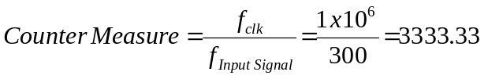

the number of bits taken up by this count is:-

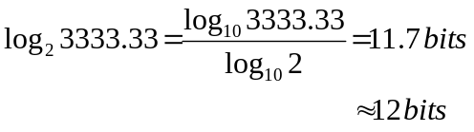

The actual binary value which will appear in the counter will be
1
1
0
1
0
0
0
0
0
1
0
1

Figure 1.1 Contents of a counter, incoming data operating at 300 baud

The baud rate of an incoming signal is 600 baud (600 bits/sec) i.e. 1 bit will take 1.67 milliseconds to pass a stationary point. The operating frequency of the counter is 1Mhz i.e. the contents of it’s stored count is updated every 1 microsecond. For one bit of incoming data, the decimal count measure will be:-

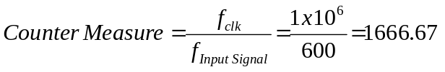

the number of bits taken up by this count is:-

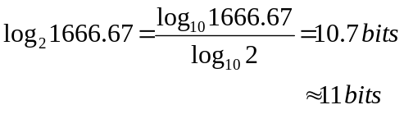

The actual binary value which will appear in the counter will be
1
1
0
1
0
0
0
0
0
1
0
0

Figure 1.2 Contents of a counter, incoming data operating at 600 baud

The baud rate of an incoming signal is 1200 baud (1200 bits/sec) i.e. 1 bit will take 0.83 milliseconds to pass a stationary point. The operating frequency of the counter is 1Mhz i.e. the contents of it’s stored count is updated every 1 microsecond. For one bit of incoming data, the decimal count measure will be:-

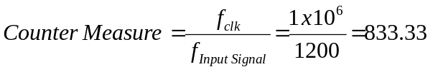

the number of bits taken up by this count is:-

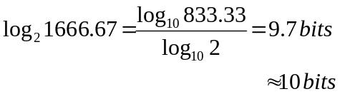

The actual binary value which will appear in the counter will be
1
1
0
1
0
0
0
0
0
1
0
0

Figure 1.3 Contents of a counter, incoming data operating at 1200 baud

1.1.1 Notes on the counters contents:

Comparing the contents of the counter for baud rates of 300, 600 and 1200 baud, there is a pattern, this is true for the higher baud rates too. The number of bits contained in the counter is halved as the baud rate is doubled. Halving the value of the counters contents is equivalent to shifting all the bits to the right, and insert a zero into the left most block of the counter.

Knowing that the highest baud rate is 19200, which is equivalent to having 6 bits of the counter filled with data. The only item of real importance is the MSB of the data obtained in the counter. The MSB is the indicator of the baud rate, the other bits in the counter can therefore be ignored. This has its advantages, if the counter is itself erroneous, counting 820 as opposed to 833 for a baud rate of 600 baud, the correct baud rate will still be displayed. Hence by using the MSB as an indicator there is a smaller margin for error in the results.

It is known that the input signal S(H) to the system is :-

Start b0 b1 b2 b3 b4 b5 b6 parity stop

Measure
Speed
here

Figure 1.4 Input signal and Baud rate measurement

Knowing what the required input signal is going to be an ASM diagram can easily be assembled, as illustrated below, using a minimal state locus (only one-bit change in the value of each of the next states) and minimal state dependency.

1.1.2 Describing the system behaviour in general

When a high-low transition occurs on input signal S(H) an enable signal is sent from the finite state machine (the controller) to counter 1. Counter 1 now begins to count, it counts until the next rising edge in signal S(H) occurs. The counter has now counted for 1 bit duration of S(H). In accordance with the value stored in the counter, the appropriate baud rate is displayed. Testing and displaying the parity will be covered in section 2.1 of the results.

1.2 ASM Controller RS232 monitor

00

F
T
S (H)
1-bit tansition
1-bit difference

01

Minimum
State
Locus
T
F
S (H)
1-bit tansition
Minimum
State
Dependency
1-bit difference
11
CT1EN (H)
UP (H)

T
S (H)
F

1-bit tansition
1-bit difference
10
DECEN (H)

Figure 1.5 ASM algorithm for ‘Measure baud rate’

From the ASM diagram, a characteristic ASM table can be derived.
As can be seen the FSM requires 2 state variables to implement the 4 states, labelled CS1 and CS0.

INPUTS | CURRENT STATE | NEXT STATE | OUTPUTS
S(H) | CS1 CS0 | NS1 NS0 | CNT1EN | DECEN
0 | 0 0 | 0 0 | 0 | 0
1 | 0 0 | 0 1 | 0 | 0
0 | 0 1 | 1 1 | 0 | 0
1 | 0 1 | 0 1 | 0 | 0
0 | 1 1 | 1 1 | 1 | 0
1 | 1 1 | 1 0 | 1 | 0
0 | 1 0 | 1 0 | 0 | 1
1 | 1 0 | 1 0 | 0 | 1

Figure 1.6 Characteristic table for RS232 Monitor (D-type implementation)

1.2.1 Next State Logic

By the use of Karnaugh maps, the next state logic can be sufficiently minimised by grouping together like minterms (maxterms could be used instead).

NS1
S, CS1
CS0
 | 00 | 01 | 11 | 10
0 | 0 | 1 | 1 | 0
1 | 1 | 1 | 1 | 0
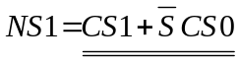
NS0
S, CS1
CS0
 | 00 | 01 | 11 | 10
0 | 0 | 0 | 0 | 1
1 | 1 | 1 | 0 | 1

Figure 1.7 Karnaugh Maps for N.S.L 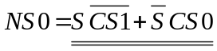

The next state can now be realised using the schematic capture tool, delivering the following image.

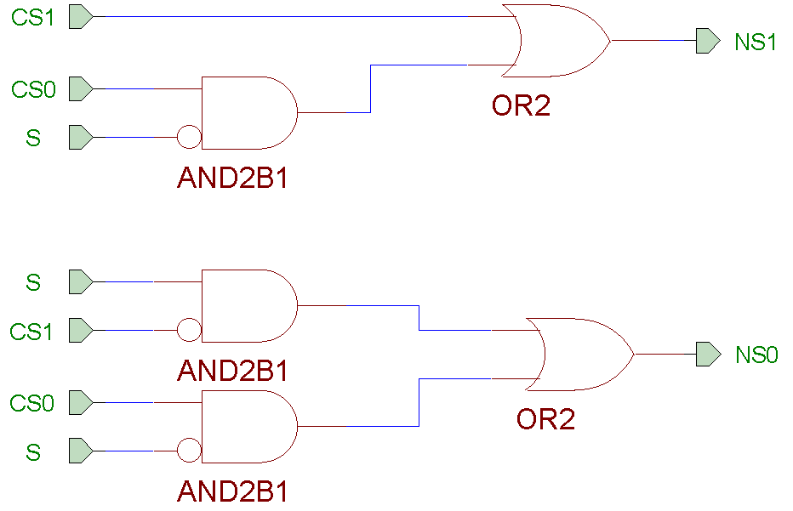

Figure 1.8 Next State Logic

1.2.2 State Output Logic

Observe the ASM table, there are two minterms for the output signal CT1EN and DECEN. The State outputs are directly related to the current state of the FSM, these are just as easily read off and simplified where possible.

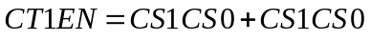

The two OR’ed terms are the same, hence the output signal CT1EN simplifies to

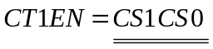

Similar to the case above, output signal DECEN is ‘high when

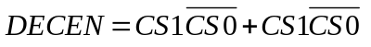

this can be simplified to

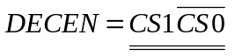

The State Output Logic can be realised using the schematic capture tool, delivering the following image.

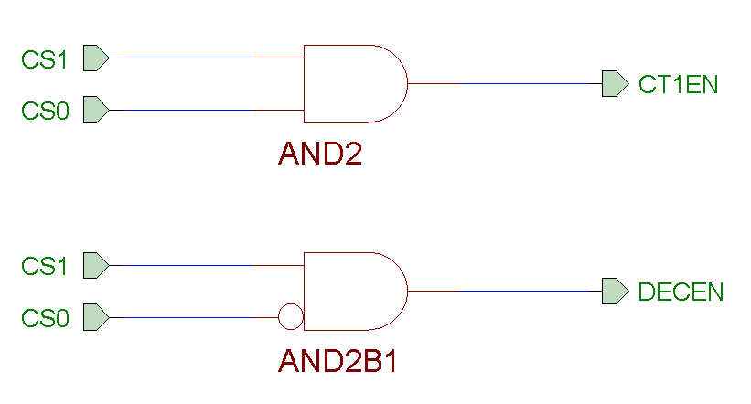
Figure 1.9 State Output Logic

With all the combinational logic derived for the finite state machine; it can now be captured schematically and tested using the functional simulator.

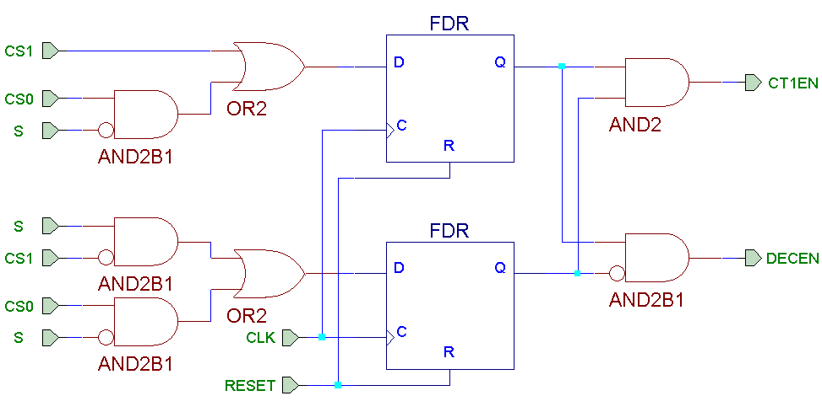

Figure 1.10 ASM Controller RS232 Monitor

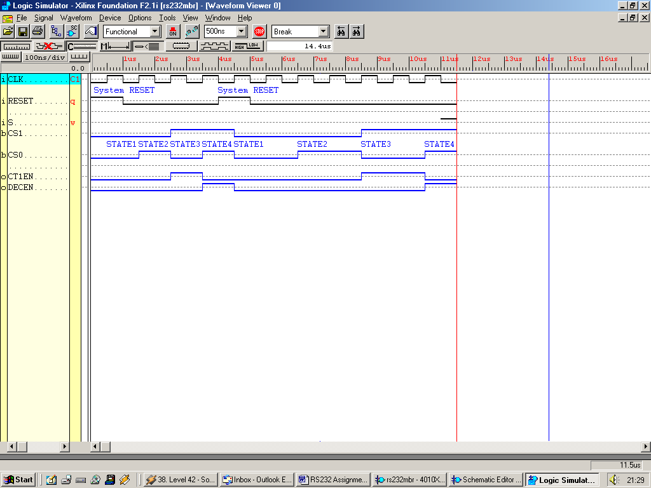

Figure 1.11 Simulation Results for ASM Controller RS232 Monitor

The finite state machine is now complete, after been implemented and simulated. Now, in order for the baud rate to be measured, the signals need to be processed (as the design study suggests) by a counter and decoder.

1.3.1 The Baud Rate Decoder

The decoder could easily be derived as shown above in the ASM Controller, by linking minterms (or maxterms) with the appropriate input. Another way of handling a decoder is simply through behavioural VHDL. If an event on the input occurs, provide the appropriate output, easy. Shown below is the decoder that describes the behaviour of the “Baud Rate Decoder.”

Entity Decoder is
Port (DECEN, RESET, B11, B10, B9, B8, B7, B6 : IN BIT;
S300, S600, S1200, S2400, S4800, S9600, S19200 : OUT BIT);
End Entity Decoder;

Architecture Decoder_Arch of Decoder is
Begin
Decod : Process (DECEN, RESET, B11, B10, B9, B8, B7, B6)
Begin
IF RESET = '1' THEN
S300 <= '0'; S600 <= '0'; S1200 <= '0'; S2400 <= '0';
S4800 <= '0'; S9600 <= '0'; S19200 <= '0';

ELSIF RESET = '0' AND DECEN = '1' THEN
IF B11 = '1' THEN
S300 <= '1';
ELSIF B11 = '0' AND B10 = '1' THEN
S600 <= '1';
ELSIF B11 = '0' AND B10 = '0' AND B9 = '1' THEN
S1200 <= '1';
ELSIF B11 = '0' AND B10 = '0' AND B9 = '0' AND B8 = '1'
THEN S2400 <= '1';
ELSIF B11 = '0' AND B10 = '0' AND B9 = '0' AND B8 = '0'
AND B7 = '1' THEN
S4800 <= '1';
ELSIF B11 = '0' AND B10 = '0' AND B9 = '0' AND B8 = '0'
AND B7 = '0' AND B6 = '1' THEN
S9600 <= '1';
ELSIF B11 = '0' AND B10 = '0' AND B9 = '0' AND B8 = '0'
AND B7 = '0' AND B6 = '0' THEN
S19200 <= '1';
END IF;
END IF;
End Process Decod;
END Architecture Decoder_Arch;

Figure 1.12 VHDL Script describing the behaviour of the decoder

To allow connectivity between VHDL and schematic components, a macro of the decoder is created. The macro is created from the synthesis net list. Displayed as a box on the schematic capture facility, with inputs and outputs referring to the port declaration in the ENTITY statement.

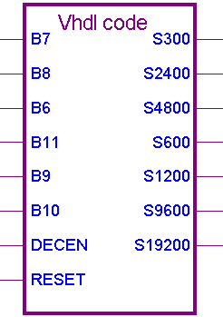
Output of device, S300 – S19200, relates to the appropriate baud rates.
Inputs (B6 – B11) connected to (Q6 – Q11) of the counter

DECEN is the Enabling input for the decoder

RESET resets the output of the device

Figure 1.13 Schematic of the Decoder Macro

1.3.2 Decoder Simulation Results

Observe the VHDL script for the decoder (shown in Figure 1.12), notice the hierarchy, using the IF THEN ELSIF syntax read from top to bottom. The behaviour can be derived from the VHDL script. The low-down is when RESET is low and DECEN is high, signal BX where X is a number from 6 to 11; the higher X is the greater it’s dominance on the output. So when B11 is high, B6 – B10 will not change the baud rate. I.e. The most significant bit in the counter determines the baud rate on test.

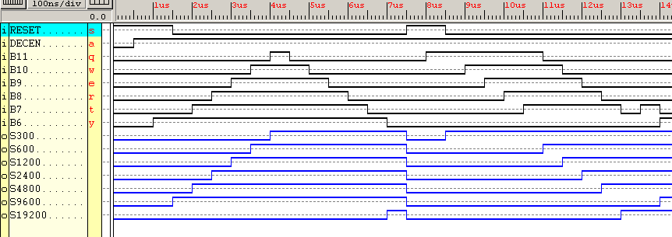

Figure 1.14 Simulation results for the VHDL macro Decode

1.4.1 The Counter

The design study specification stipulates a 12-bit up-counter is required. In the Xilinx XC4000XL library, a 12-bit counter is not present, the closest component to it is a 16-bit up-counter, the upper 4-bits of the output bus will not be used. Remember from previous results, the largest value the counter will hold is a 12-bit value referring to a baud rate of 300 bits/sec. Out of the 12-bits only the 6 most significant bits will be used to transport data i.e. bits [6 to 11]. The upper 6-bits correspond to the 7 available baud rates.

Shown below is a schematic of the counter, called CB16RE, this is a 16-bit binary counter with clock enable and synchronous reset.

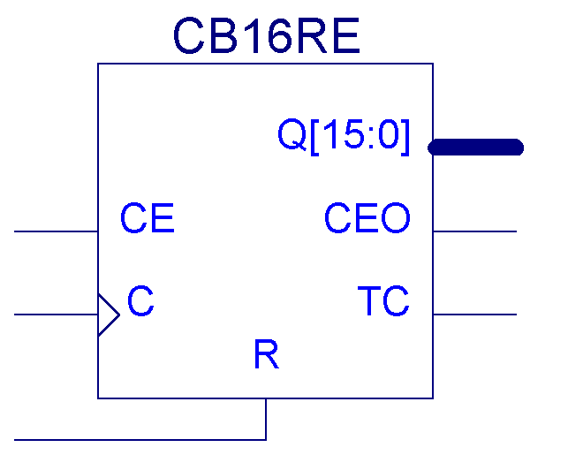
Outputs Count to the baud rate decoder
Receives an enable signal from the ASM controller, enabling the device to up-count
Figure 1.15 Schematic of CT1

Looking at the schematic for a moment, all ports will be used with the exception of CEO and TC which represent clock enable equals zero and terminal count respectively. The clock enable input port is connected directly to CT1EN output on the finite state machine. Lets look at the simulation results of this schematic.
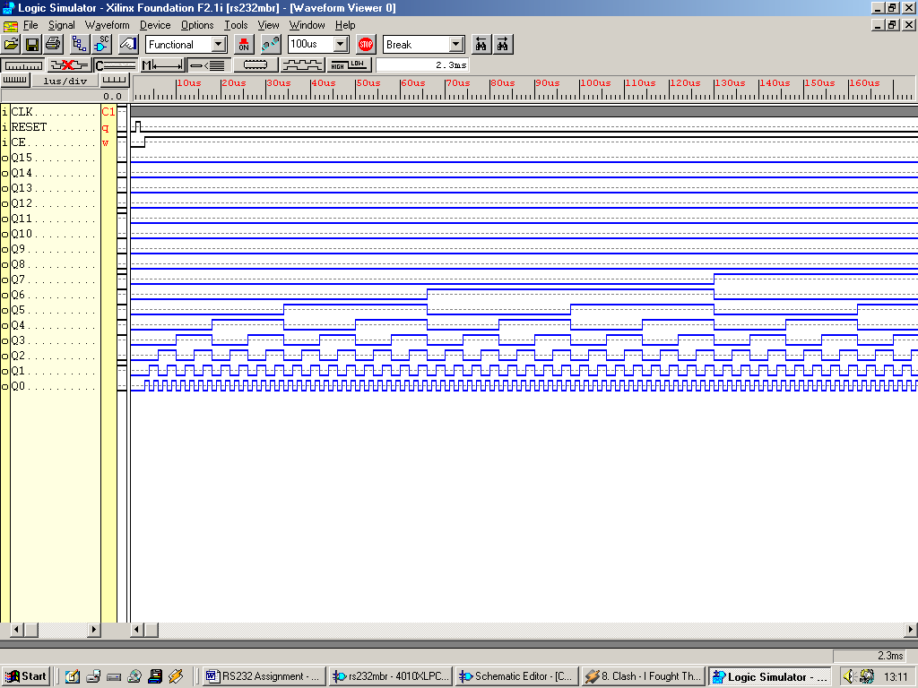

Figure 1.16 Simulation results for the component CT1

The results above show that when the clock enable signal is high and the reset input is low, on the rising edge of the clock, 1 is added to the contents of the counter. Output Q15 is the MSB of the counter, hence Q0 is the LSB, the clock signal is a grey mass because of scale used.

1.5.1 Complete “Measure Baud Rate” System

With all the individual entities working independently, the next logical step is to connect them together and see if the complete system operates correctly. Shown below is the whole system, notice the input signal (S) goes through an inverter. The incoming signal is an inverted version of $.

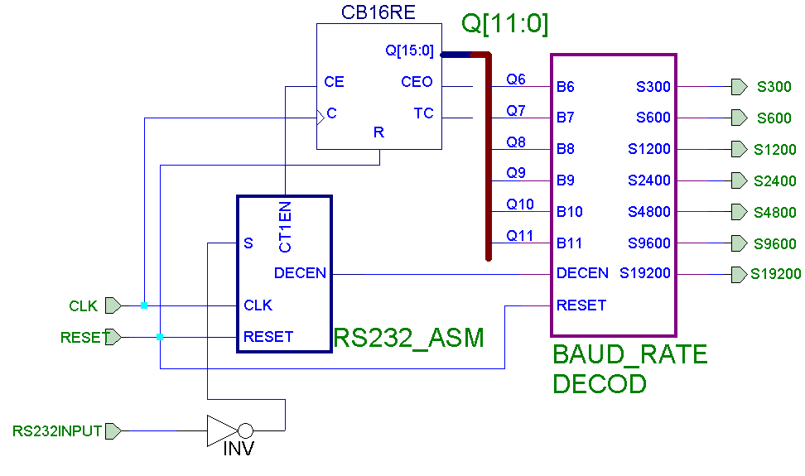

Figure 1.17 Schematic of “Measure Baud Rate” System

The test signal used on this system is an inverted version of that seen in Figure 1.4. Because of the time required for simulation and for viewing purposes, the time scales for the clock and input signal have both been scaled by a factor of 1000. This will still give the correct results, but under a much smaller time scale.
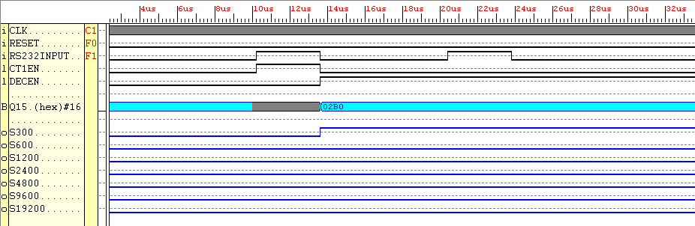

Figure 1.18 Simulation results of the whole system, input signal S working at
300 baud

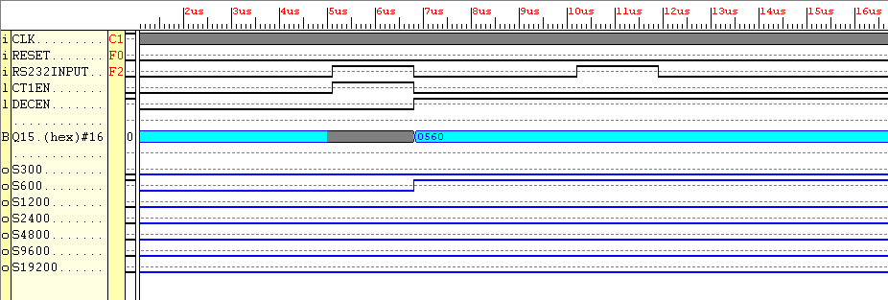

Figure 1.19 Simulation results of the whole system, input signal S working at
600 baud

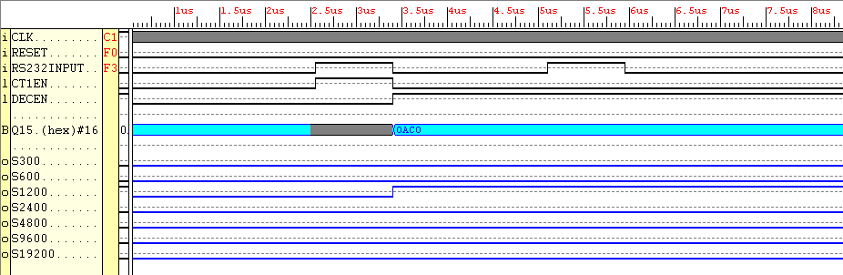

Figure 1.20 Simulation results of the whole system, input signal S working at
1200 baud

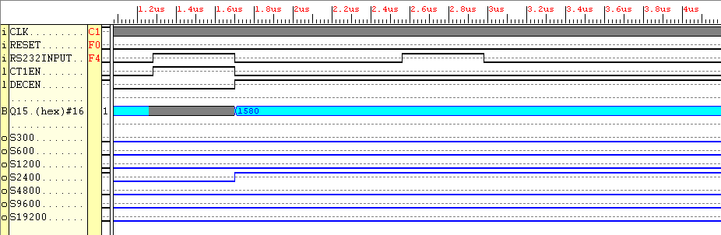

Figure 1.21 Simulation results of the whole system, input signal S working at
2400 baud

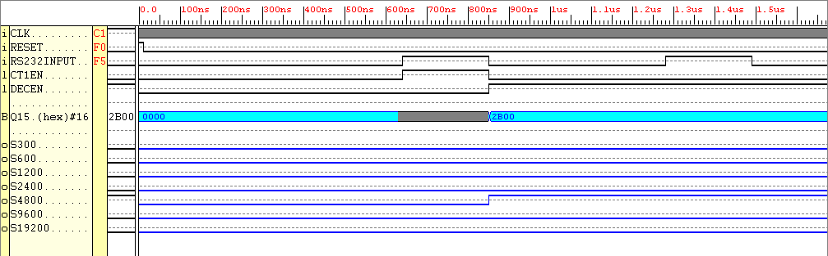

Figure 1.22 Simulation results of the whole system, input signal S working at
4800 baud
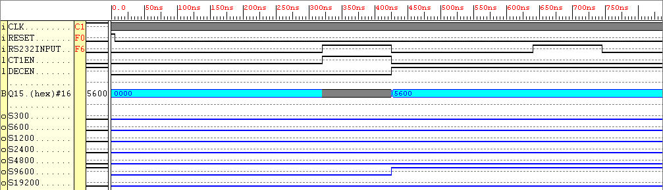

Figure 1.23 Simulation results of the whole system, input signal S working at
9600 baud

1.5.2 Explanation of simulation results

The curly arrows are a representation of event occurances.

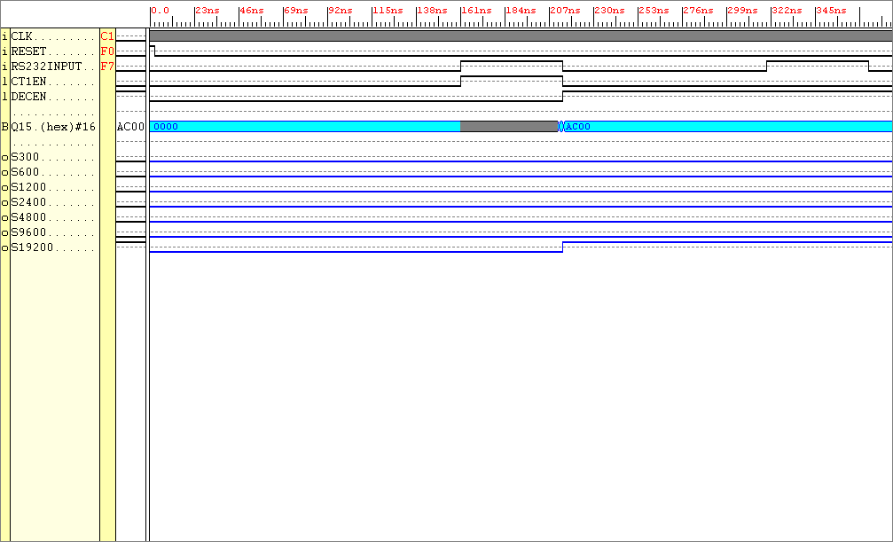

Figure 1.24 Simulation results of the whole system, input signal S working at
19200 baud

The above simulation results all have the same characteristics. This section was a stage to see how digital design methodology is used to solve the problem of “how is the baud rate of a signal achieved”. The system sees four tenths of the RS232_Input i.e. up to the 1 > 0 transition. I will begin to describe the behaviour observed in the simulation results, take figure 1.24 as an example and using a copy of the ASM controller (shown in Figure 1.25) as a guide. The input signal’s (RS232_INPUT) initial transitions from 0 to 1 and 1 to 0 is replicated in the outputted enable signal from the controller, counter 1 enable (CT1EN). This enable signal triggers the counter to up-count, until it’s removed. Once removed a state change occurs, signal (DECEN) is placed on enabling the baud rate to be seen. Because of the resolution used in these results a grey mass is formed on Q15, which should represent increments in the count.
T
00
11
01
CT1EN (H)
UP (H)
S (H)
S (H)
S (H)
T
T
F
F
F
10
DECEN (H)
Figure 1.25 ASM algorithm for ‘Measure baud rate’

2.1.1 Measure Baud Rate and Test Parity

The second part to this design study requires one to measure the baud rate of the RS232 input. Once known, this figure can be used in an attempt to test the parity bit of the RS232 input.
Measure
Speed
here
Test
Parity
here

4 and a half periods

START B0 B1 B2 B3 B4 B5 B6 B7 STOP
Figure 2.1 Input signal and parity bit sampling technique

The circuit is required to sample the incoming signal in the middle of the parity bit and display the parity. The ASM algorithm for ‘Test Parity’ mentioned in the case study text seems over exaggerated. Two extra counters are used in the DSP, at the end of the day this extra logic is unneeded. The design can be implemented using one counter which can up-count, load, then used as down-counter which then triggers the sampling of the parity. Such a counter can be found in the Xilinx XC4000XL library, named CB16CLED. The schematic for this device is shown below.
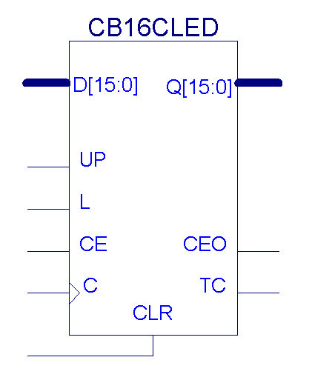
Figure 2.2 A schematic of the 16-bit loadable up-down counter (CB16CLED)

The data sheet describing the behaviour of the counter can be found in the appendix of this report. Not all the ports on this device will be utilised, output port TC will be left unconnected. Output CEO (count equals zero) will be used to communicate with the controller to tell it when the count down equals zero.
The controller will then output an enabling signal to the “Parity Tester”, which will then sample the parity.
2.1.2 The Full ASM Controller RS232 monitor

Having one counter in mind which does three jobs, a different ASM diagram will need to be generated than that specified in the design study. From the ASM algorithm created in Section 1, the algorithm created to display the parity logically follows on. Knowing what the controller needs to do in order to test the parity, a number of ordered steps can be written down and utilised in the overall integrated ASM algorithm.

Test parity Algorithm

- Measure Baud Rate (covered in Section 1) Enable “Count down” decoder

- The “Count down” decoder, decodes baud rate, outputs count required for counter to count the 4.5 periods to parity bit.

- Load Counter with the required count down time.

- Enable Counter

- Are the contents of the counter are zero?

If no, continue checking every clock tick.

If yes, enable the parity decoder, display the parity.

- Loop forever until reset (power up).

010
000
DECEN = '1'
CDDEN = '1'

T
F
S = '1'
110
LOAD = '1'

001

111
S = '1'
T
F
CT1EN = '1'

T
F
CEO = '1'
011
CT1EN = '1'
UP = '1'

T
F
101
PTEN = '1'
S = '1'

100

Figure 2.3 Completed ASM Diagram
Looking at Figure 2.3, it can be seen that the system will operate through 8 states which requires log₂8 state variables. Again it has a minimum state locus and minimum state dependency. This system still requires exactly the same amount of states as that of the ASM algorithm specified in the design study, but with two less counters.

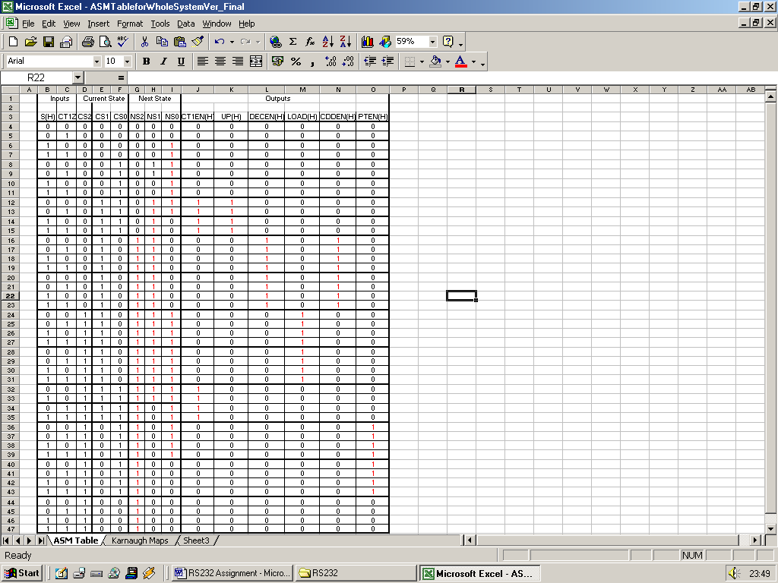

Figure 2.4 Characteristic table for Final RS232 Monitor (D-type implementation)

2.1.3 Next State Logic

Again the next logical step in the digital design process is to process the data obtained in the ASM table into Karnaugh maps. By the use of five variable Karnaugh maps, the next state logic can be sufficiently minimised by grouping together like minterms (maxterms could also be used). Minterms can be grouped which are in the same place either side of the middle line.

NS2 |  |  |  |  |  | S(H)
 |  |  |  | CT1Z
 | *000 | *001 | *011 | *010 | *110 | *111 | *101 | *100
*00 |  | 1 | 1 |  |  | 1 | 1
*01 |  | 1 | 1 |  |  | 1 | 1
*11 |  | 1 | 1 |  |  | 1 | 1 |  | CS1
*10 | 1 | 1 | 1 | 1 | 1 | 1 | 1 | 1
 |  | CS2 |  |  |  | CS2

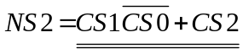

NS1 |  |  |  |  |  | S(H)
 |  |  |  | CT1Z
 | *000 | *001 | *011 | *010 | *110 | *111 | *101 | *100
*00
*01 | 1 |  |  | 1
*11 | 1 | 1 |  | 1 | 1 |  | 1 | 1 | CS1
*10 | 1 | 1 | 1 | 1 | 1 | 1 | 1 | 1
 |  | CS2 |  |  |  | CS2

 |  |  |  |  |  | S(H)
 |  |  |  | CT1Z
 | *000 | *001 | *011 | *010 | *110 | *111 | *101 | *100
*00 |  |  |  |  | 1 |  |  | 1
*01 | 1 |  |  | 1 | 1 |  |  | 1
*11 | 1 | 1 | 1 | 1 |  | 1 | 1 |  | CS1
*10 |  | 1 | 1 |  |  | 1 | 1
 |  | CS2 |  |  |  | CS2

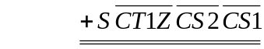

Figure 2.5 Karnaugh representation of the next state logic

That’s the next state logic complete, the state output logic now needs to be derived, and is done so in the same Karnaugh map method as shown above. Using only the minterms the output logic is derived directly from the current states in the ASM table.

2.1.4 State Output Logic

Again Using Karnaugh maps of three variables the state output logic can be obtained.

 | CT1EN |  |  | CS2
 |  |  | CS1
 |  | *00 | *01 | *11 | *10
 | *0
CS0 | *1 |  | 1 | 1

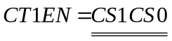

 | DECEN |  |  | CS2
 |  |  | CS1
 |  | *00 | *01 | *11 | *10
 | *0 |  | 1
CS0 | *1

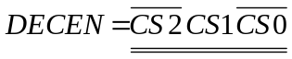

 | CDDEN |  |  | CS2
 |  |  | CS1
 |  | *00 | *01 | *11 | *10
 | *0 |  | 1
CS0 | *1

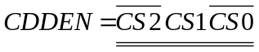

 | UP |  |  | CS2
 |  |  | CS1
 |  | *00 | *01 | *11 | *10
 | *0
CS0 | *1 |  | 1

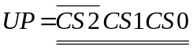

 | LOAD |  |  | CS2
 |  |  | CS1
 |  | *00 | *01 | *11 | *10
 | *0 |  |  | 1
CS0 | *1

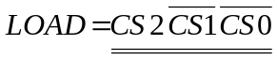

 | PTEN |  |  | CS2
 |  |  | CS1
 |  | *00 | *01 | *11 | *10
 | *0
CS0 | *1 |  |  |  | 1

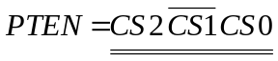
Figure 2.6 Karnaugh representation of the state output logic

Now that the next state and output logic has been derived, the ASM controller can be implemented. Logically one might think create a schematic capture of the logic, because I’m now familiar with the alternative VHDL method I’ll use that instead, because it’s a much more powerful method of creating digital systems. The ASM controller could have been implemented using behavioural VHDL, instead I’ve opted to use the structural model. Note I’ve instantiated my own behavioural flip flop model, which at the end of the day is a vast waste of logic. I should have used the target library from the beginning, using Xilinx XC4000XL FPGA specific components instead of my own. Anyway, here’s the VHDL script used:

-- Created by David Clarke for the RS232 assignment
library IEEE;
use IEEE.STD_LOGIC_1164.ALL;

Entity RS232_ASM IS
Port (CT1Z, S, CLK, CLR : IN STD_LOGIC; CT1EN, UP, DECEN, LOAD, CDDEN, PTEN : OUT STD_LOGIC);
End Entity RS232_ASM;

Architecture Structural of RS232_ASM IS

Component AND2 IS
Port (a, b : IN std_logic; z : OUT std_logic);
END Component AND2;

Component AND2B1 IS
Port (a, b : IN std_logic; z : OUT std_logic);
END Component AND2B1;

Component AND3B1 IS
Port (a, b, c : IN std_logic; z : OUT std_logic);
END Component AND3B1;

Component AND3B2 IS
Port (a, b, c : IN std_logic; z : OUT std_logic);
END Component AND3B2;

Component AND4B2 IS
Port (a, b, c, d : IN std_logic; z : OUT std_logic);
END Component AND4B2;

Component AND4B3 IS
Port (a, b, c, d : IN std_logic; z : OUT std_logic);
END Component AND4B3;

Component OR2 IS
Port (a, b : IN std_logic; z : OUT std_logic);
End Component OR2;

Component OR5 IS
Port (a, b, c, d, e : IN std_logic; z : OUT std_logic);
End Component OR5;

Component OR6 IS
Port (a, b, c, d, e, f : IN std_logic; z : OUT std_logic);
End Component OR6;

Component FDC IS
Port (D, CLK, CLR : IN std_logic; Q : OUT std_logic);
End Component FDC;

Signal CS2, CS1, CS0, NS2, NS1, NS0 : std_logic;
Signal NS2_OR2_1 : std_logic;
Signal NS1_OR5_1, NS1_OR5_2, NS1_OR5_3, NS1_OR5_4, NS1_OR5_5 : std_logic;
Signal NS0_OR6_1, NS0_OR6_2, NS0_OR6_3, NS0_OR6_4, NS0_OR6_5, NS0_OR6_6 : std_logic;

Begin

NS2_AND2B1 : AND2B1 port map (a => CS1, b => CS0, z => NS2_OR2_1);
NS2_OR2 : OR2 port map (a => CS2, b => NS2_OR2_1, z => NS2);
-- Conectivity for NS2 combinational logic
FDC2 : FDC port map (D => NS2, CLK => CLK, CLR => CLR, Q => CS2);
-- The above combinational logic which produced NS2 is input to a latch to produce output CS2

NS1_AND2B1 : AND2B1 port map (a => CS1, b => CT1Z, z => NS1_OR5_1);
NS1_AND3B1 : AND3B1 port map (a => CS1, b => CT1Z, c => CS2, z => NS1_OR5_2);
NS1_AND2B1_2 : AND2B1 port map (a => CS1, b => CS0, z => NS1_OR5_3);
NS1_AND4B3 : AND4B3 port map (a => CS0, b => CS2, c => CT1Z, d => S, z => NS1_OR5_4);
NS1_AND4B2 : AND4B2 port map (a => CS0, b => CT1Z, c => CS2, d => S, z => NS1_OR5_5);
NS1_OR5 : OR5 port map (a => NS1_OR5_1, b => NS1_OR5_2, c => NS1_OR5_3,
d => NS1_OR5_4, e => NS1_OR5_5, z => NS1);
-- Conectivity for NS1 combinational logic
FDC1 : FDC port map (D => NS1, CLK => CLK, CLR => CLR, Q => CS1);
-- The above combinational logic which produced NS2 is input to a latch to produce output CS1

NS0_AND2 : AND2 port map (a => CS2, b => CS1, z => NS0_OR6_1);
NS0_AND3B1 : AND3B1 port map (a => CS1, b => CS0, c => S, z => NS0_OR6_2);
NS0_AND4B3 : AND4B3 port map (a => CS0, b => S, c => CT1Z, d => CS2, z => NS0_OR6_3);
NS0_AND4B2 : AND4B2 port map (a => CT1Z, b => CS0, c => CS2, d => CS1, z => NS0_OR6_4);
NS0_AND4B2_2 : AND4B2 port map (a => S, b => CT1Z, c => CS2, d => CS1, z => NS0_OR6_5);
NS0_AND4B3_2 : AND4B3 port map (a => S, b => CT1Z, c => CS2, d => CS1, z => NS0_OR6_6);
NS0_OR6 : OR6 port map (a => NS0_OR6_1, b => NS0_OR6_2, c => NS0_OR6_3, d => NS0_OR6_4,
e => NS0_OR6_5, f => NS0_OR6_6, z => NS0);
--Connectivity for NS0 combinational logic
FDC0 : FDC port map (D => NS0, CLK => CLK, CLR => CLR, Q => CS0);
-- The above combinational logic which produced NS2 is input to a latch to produce output CS0

OUTPUT_AND2 : AND2 port map (a => CS1, b => CS0, z => CT1EN);
OUTPUT_AND3B1 : AND3B1 port map (a => CS0, b => CS1, c => CS2, z => UP);
OUTPUT_AND3B2 : AND3B2 port map (a => CS1, b => CS0, c => CS2, z => DECEN);
OUTPUT_AND3B1_1 : AND3B1 port map (a => CS2, b => CS1, c => CS0, z => LOAD);
OUTPUT_AND3B2_2 : AND3B2 port map (a => CS1, b => CS2, c => CS0, z => CDDEN);
OUTPUT_AND3B1_2 : AND3B1 port map (a => CS2, b => CS0, c => CS1, z => PTEN);
-- State output logic
END Architecture Structural;

Figure 2.7 VHDL script describing the RTL of the ASM controller

2.1.5 ASM Controller Simulation Results

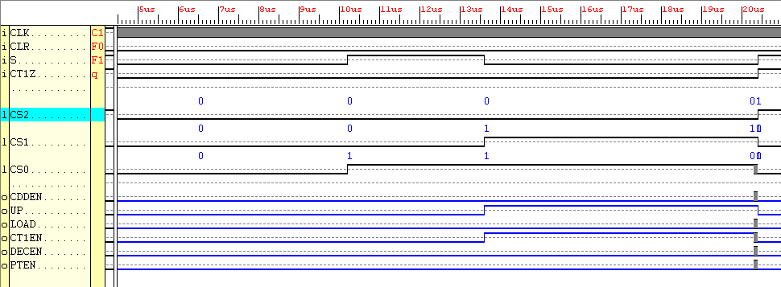

Figure 2.7 Simulation results for the ASM Controller

Observe the post-synthesis simulation results, following the ASM diagram shown in Figure 2.1, it can be seen that the state machine follows correctly.
- The initial state change is caused by a change in Input ‘S’ from logic ‘0’ to logic ‘1’.
- The second state change is again caused by a change in Input ‘S’ from logic ‘1’ to logic ‘0’.
- The third state change is better illustrated in the diagram below, the resolution used in the simulation results above is too low. When ‘S’ goes high on the rising edge of the following clock transition, output signal CDDEN and DECEN go ‘high, all other outputs go ‘low.
- The fourth state change is induced by the next rising edge of the clock. This causes output signals CDDEN and DECEN go ‘low and for LOAD to go high. The fifth state change is again induced by the next rising edge of the clock. This causes output signal LOAD to go ‘low, and forcing CT1EN ‘high.
- The sixth state change is caused by input signal CT1Z going ‘high, which leads to two further state changes where PTEN is outputted, followed by nothing on it’s output.

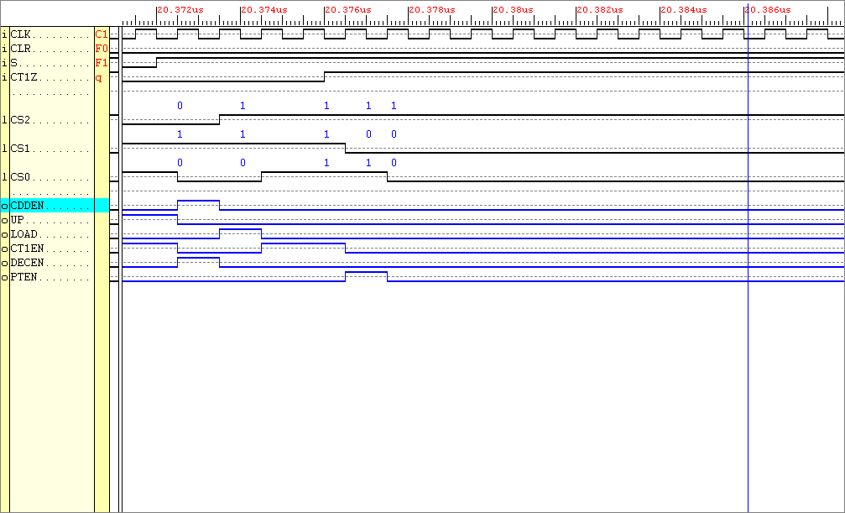

Figure 2.8 High res’ results outlined in Figure 2.4 with a dashed box
In order for the system to operate, included in the DSP are a number of decoders. These include “The Parity Decoder”, “The Count Down Timer Decoder” and “ The Pin Out Decoder”.

2.2.1 The Parity Decoder

“The Parity Decoder” when enabled by “ASM Controller”, samples the incoming data S and outputs the parity. Output EVEN goes ‘high when the tested parity is even, Output ODD goes ‘high when the tested parity is odd, simple. The VHDL behavioural algorithm used to create this is also simple in structure.

-- Created by David Clarke for the RS232 assignment
Library IEEE;
USE IEEE.STD_LOGIC_1164.All;

Entity Parity_Test IS
PORT (CLR, PTEN, S : IN STD_LOGIC; EVEN, ODD : OUT STD_LOGIC);
END Parity_Test;
--
Architecture Parity_Test_Arch OF Parity_Test IS
Begin
Process (CLR, PTEN, S)
Begin
IF CLR = '1' THEN
EVEN <= '0'; ODD <= '0';
ELSIF PTEN = '1' THEN
IF S = '0' THEN
ODD <= '1'; EVEN <= '0';
ELSIF S = '1' THEN
EVEN <= '1'; ODD <= '0';
END IF;
END IF;
END Process;
End Architecture Parity_Test_Arch;

Figure 2.9 VHDL description of the Parity Tester

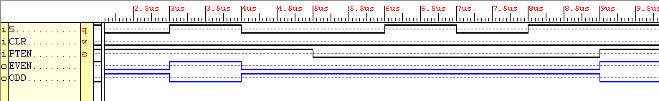

Figure 2.10 Parity tester simulation results

2.2.2 The Count Down Timer Decoder

The count down timer decoder is a personal creation, not mentioned in the design study it’s purpose can be described in a number of steps:

When enabled, the decoder sees what input is live, each input corresponds to a baud rate taken straight from the outputs of the baud rate decoder.

The count down timer decoder, knowing what the baud rate is of the input signal S, uses a LUT and outputs a 16-bit value corresponding to 4.5 times (4.5 times the period for one bit) the count for one bit of the input signal S.

This value is then passed to the 16-bit counter, for it to count down 4.5 periods for a parity test to take place. The counter is described earlier on in the Section. The VHDL decoder algorithm is again a simple behavioural model.

-- Created by David Clarke for the RS232 assignment
library IEEE;
USE IEEE.STD_LOGIC_1164.all;

ENTITY CDDECODE IS
PORT (CDDEN, CLR, S19200, S9600, S4800, S2400, S1200, S600, S300 : IN STD_LOGIC; CNT : OUT STD_LOGIC_VECTOR (15 downto 0));
END ENTITY CDDECODE;
--
ARCHITECTURE CDDECODE_ARCH OF CDDECODE IS
BEGIN

PROCESS (CDDEN, CLR, S19200, S9600, S4800, S2400, S1200, S600, S300)
BEGIN
IF CLR = '1' THEN
CNT <= "0000000000000000";

ELSIF CDDEN = '1' AND CLR = '0' THEN
IF S300 = '1' THEN CNT <= "0011101010011000";
ELSIF S600 = '1' THEN CNT <= "0001110101001100";
ELSIF S1200 = '1' THEN CNT <= "0000111010100110";
ELSIF S2400 = '1' THEN CNT <= "0000011101010011";
ELSIF S4800 = '1' THEN CNT <= "0000001110101001";
ELSIF S9600 = '1' THEN CNT <= "0000000111010100";
ELSIF S19200 = '1' THEN CNT <= "0000000011101010";
END IF;
END IF;
END PROCESS;
END ARCHITECTURE CDDECODE_ARCH;

Figure 2.11 VHDL description of the Count Down Timer Decoder

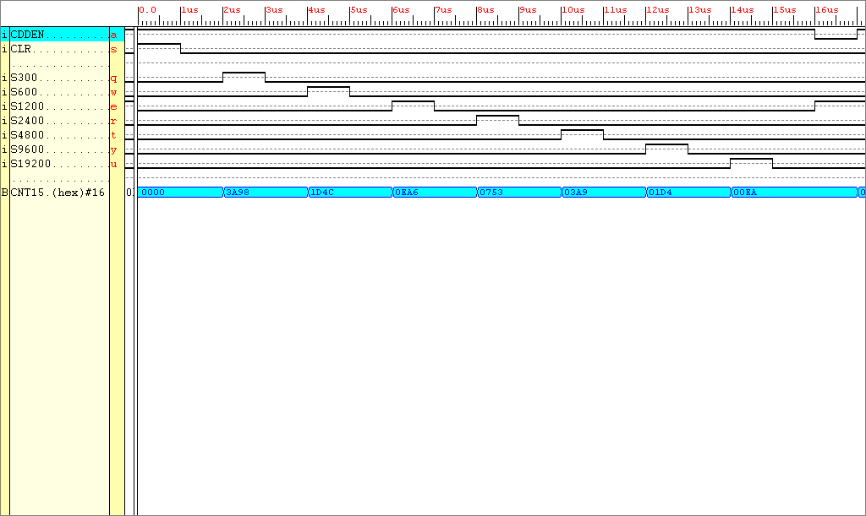

Figure 2.12 The Count Down Timer Decoder simulation results

The simulation results needs further explanation over what has already been explained so far. Only one input can be live at any one time, remembering the RS232 input can be only one baud rate per test run. Hence only one Baud rate input is live at any one instance. Notice when the input S300 goes high (baud rate equals 300 bits/sec) this causes an event to happen on the output. The number outputted by the system is in hexadecimal format on the simulation results. The decimal equivalent of the above outputted hex’ number is as follows:

3A98 (hexadecimal) = 0011 1010 1001 1000 (binary) = 15000 (decimal) = 4.5 x 3333.33

4.5 periods Decimal Count stored in counter for one period for a baud rate of 300

The same rule applies to the other outputted hexadecimal values.

2.2.3 The Pin out Decoder

The pin out decoder was primarily created in order for the baud rate to be displayed on the XS40’s seven segment LED display. If the baud rate of the signal was set at 300, then tested, the LED display would output a 1 using two segments. A signal with baud rate 600 bits/sec would cause a 2 to be outputted on the LED display using five segments etc. The highest baud rate 19200 would shown up on the LED display as 7. Output signals S0 through to S6 map directly onto associated inputs of the seven segments of the LED.

-- Created by David Clarke for the RS232 assignment
Library IEEE;
USE IEEE.STD_LOGIC_1164.All;

Entity Pinoutdecode IS
Port (CLR, S300, S600, S1200, S2400, S4800, S9600, S19200 : IN
STD_LOGIC; S6, S5, S4, S3, S2, S1, S0 : OUT STD_LOGIC);
End Entity Pinoutdecode;
--
Architecture Arch OF Pinoutdecode IS
Begin

Process (CLR, S300, S600, S1200, S2400, S4800, S9600, S19200)

Begin
IF CLR = '1' THEN
S6 <= '0'; S5 <= '0'; S4 <= '0'; S3 <= '0'; S2 <= '0';
S1 <= '0'; S0 <= '0';
ELSIF CLR = '0' THEN
IF S300 ='1' THEN
S6 <= '0'; S5 <= '0'; S4 <= '1'; S3 <= '0';
S2 <= '0'; S1 <= '1'; S0 <= '0';
ELSIF S600 = '1' THEN
S6 <= '1'; S5 <= '0'; S4 <= '1'; S3 <= '1';
S2 <= '1'; S1 <= '0'; S0 <= '1';
ELSIF S1200 = '1' THEN
S6 <= '1'; S5 <= '0'; S4 <= '1'; S3 <= '1';
S2 <= '0'; S1 <= '1'; S0 <= '1';
ELSIF S2400 = '1' THEN
S6 <= '0'; S5 <= '1'; S4 <= '1'; S3 <= '1';
S2 <= '0'; S1 <= '1'; S0 <= '0';
ELSIF S4800 = '1' THEN
S6 <= '1'; S5 <= '1'; S4 <= '0'; S3 <= '1';
S2 <= '0'; S1 <= '1'; S0 <= '1';
ELSIF S9600 = '1' THEN
S6 <= '1'; S5 <= '1'; S4 <= '0'; S3 <= '1';
S2 <= '1'; S1 <= '1'; S0 <= '1';
ELSIF S19200 = '1' THEN
S6 <= '1'; S5 <= '0'; S4 <= '1'; S3 <= '0';
S2 <= '0'; S1 <= '1'; S0 <= '0';
END IF;
END IF;
END Process;
END Architecture Arch;

Figure 2.13 VHDL description of the Pin Out Decoder

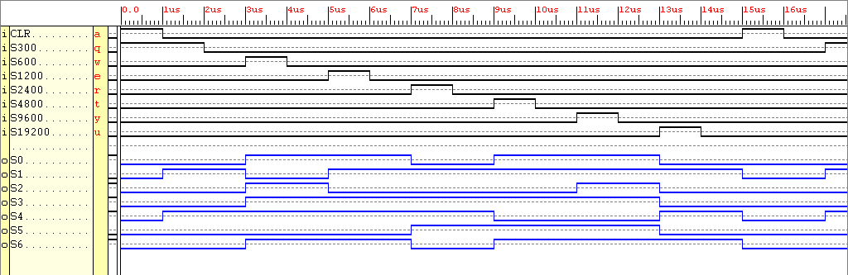

Figure 2.14 Pin Out Decoder simulation results

As explained earlier only one input to the decoder can be live at any one time, remembering the RS232 serial data stream input can be only one baud rate per test. Shown below is the seven segment display, from the results one can visualise the number displayed for each of the different baud rates. For example, when the baud rate is 2400 bits/sec, segments S1, S3, S4 and S5 are live, all other segments are off. On the seven segment display a four (an upside down reflected h) will appear, relating to the fourth slowest baud rate available.
S6

S5
S4
S3

S2
S1
S0

Figure 2.15 Schematic of a seven segment display

Now that each individual entity which makes up the complete system has now been realised and tested the Integration of DSP subsystems with the ASM controller can now be undertaken.

2.3.1 Complete “Measure Baud Rate and Output Parity” System

With a hierarchical approach to the design of the complete system. The whole system is viewed as one entity with sub entities joined together. Hence within the entity named “Whole_System”, the sub components such as the decoders ASM controller and counter are declared and instantiated. This hierarchical view allows a neater layout of the “Whole_System” to be developed. The higher level of abstraction allows also a simpler understanding of how the system looks on paper.

-- Created by David Clarke for the RS232 assignment
Library IEEE;
USE IEEE.std_logic_1164.all;

Entity Whole_system IS
Port (RS232_input, CLR, CLK : IN STD_LOGIC; EVEN, ODD, S6, S5, S4, S3, S2, S1, S0 : OUT STD_LOGIC);
End Entity Whole_system;
--
Architecture Structural of Whole_system IS
-- Component declaration area
Component Decoder IS
PORT (DECEN, CLR : IN STD_LOGIC; Q11, Q10, Q9, Q8, Q7, Q6 : IN STD_LOGIC;
S300, S600, S1200, S2400, S4800, S9600, S19200 : OUT STD_LOGIC);
END Component Decoder;

Component INV IS
PORT (a : IN STD_LOGIC; z : OUT STD_LOGIC);
END Component INV;

Component CDDECODE IS
PORT (CDDEN, CLR, S19200, S9600, S4800, S2400, S1200, S600, S300 : IN STD_LOGIC; CNT : OUT STD_LOGIC_VECTOR (15 downto 0));
END Component CDDECODE;

Component Parity_Test IS
PORT (CLR, PTEN, S : IN STD_LOGIC; EVEN, ODD : OUT STD_LOGIC);
END Component Parity_Test;

Component Pinoutdecode IS
Port (CLR, S300, S600, S1200, S2400, S4800, S9600, S19200 : IN STD_LOGIC; S6, S5, S4, S3, S2, S1, S0 : OUT STD_LOGIC);
End Component Pinoutdecode;

Component cb16cled IS
port (D : in STD_LOGIC_VECTOR (15 downto 0); Q : out STD_LOGIC_VECTOR (15 downto 0);
C, CE, CLR, L, UP : in STD_LOGIC; CEO, TC : out STD_LOGIC);
End Component CB16CLED;

Component RS232_ASM IS
port (CT1Z, S, CLR, CLK : IN STD_LOGIC; CDDEN, UP, LOAD, CT1EN, DECEN, PTEN : OUT STD_LOGIC);
End Component RS232_ASM;

Signal S, S300, S600, S1200, S2400, S4800, S9600, S19200, CT1Z, CDDEN, UP, LOAD, CT1EN, DECEN, PTEN : STD_LOGIC;
Signal Q : STD_LOGIC_VECTOR (11 downto 6);
Signal CNT : STD_LOGIC_VECTOR (15 downto 0);

Begin
-- Component instantiation region

INV1 : INV Port map (a => RS232_input, z => S);
-- The RS232_input is input to the RS232, the signal is passed through an inverter to become S

PT : Parity_Test port map (PTEN => Pten, S => S, CLR => Clr, EVEN => Even, ODD => Odd);
-- The parity tester is now physically connected to the Controller

TIME_ENCODER : CDDECODE port map (S300 => s300, S600 => s600, S1200 => s1200, S2400 => s2400, S4800 => s4800,
S9600 => s9600, S19200 => s19200, CDDEN => CDDEN, CLR => CLR,
CNT(15 downto 0) => CNT (15 downto 0));
-- The decoder before the counter is completely connected to the other components

CB16CLED_DC : CB16CLED port map (UP => up, L => Load, CE => CT1EN, C => CLK, CLR => CLR, CEO => CT1Z, D(15 downto 0) => CNT(15 downto 0), Q(11 downto 6) => Q(11 downto 6));
-- The counter is now connected to the controller

BAUDRATE_DECODE : Decoder port map (Q11 => Q(11), Q10 => Q(10), Q9 => Q(9), Q8 => Q(8), Q7 => Q(7), Q6 => Q(6), DECEN => DECEN, CLR => CLR, S300 => s300, S600 => s600, S1200 => s1200, S2400 => s2400, S4800 => s4800, S9600 => s9600, S19200 => s19200);
-- The baud rate decoder is now physically connected

LED_DISPLAY : Pinoutdecode port map (S300 => s300, S600 => s600, S1200 => s1200, S2400 => s2400, S4800 => s4800, S9600 => s9600, S19200 => s19200, S6 => s6, S5 => s5, S4 => s4, S3 => s3, S2 => s2, S1 => s1, S0 => s0, CLR => Clr);
-- The LED display is now physically connected to the system

THE_BEAST : RS232_ASM port map (CT1Z => CT1Z, S => S, CLR => CLR, CLK => CLK, CDDEN => CDDEN, UP => UP, LOAD => Load, CT1EN => CT1en, DECEN => DECEN, PTEN => PTEN);

End Architecture Structural;

Figure 2.16 VHDL script describing the structure of the RS232 Monitor

2.3.2 Results for the Whole_System

 | LED Segments |  |  |  |  |  | Baud Rate
S0 | S1 | S2 | S3 | S4 | S5 | S6 | (bits/sec)
0 | 1 | 0 | 0 | 1 | 0 | 0 | 300
1 | 0 | 1 | 1 | 1 | 0 | 1 | 600
1 | 1 | 0 | 1 | 1 | 0 | 1 | 1200
0 | 1 | 0 | 1 | 1 | 0 | 1 | 2400
1 | 1 | 0 | 1 | 0 | 1 | 1 | 4800
1 | 1 | 1 | 1 | 0 | 1 | 1 | 9600
0 | 1 | 0 | 0 | 1 | 0 | 1 | 19200

Figure 2.17 LED segment to Baud Rate conversion table

By using the baud rate conversion table shown above (if not completely satisfied that the outputted LED segment values are true, use Figure 2.15 to visualise the number produced on LED display, this will correspond to these tabular values) the results obtained in the following simulation results can be converted.
The state transitions are of a standard set of simulation timing diagram results obtained using the RS232 monitor.
F
F
T
000
010
011
001
CT1EN = '1'
UP = '1'
S = '1'
S = '1'
S = '1'
T
T
F
100
101
111
110
DECEN = '1'
CDDEN = '1'
LOAD = '1'

CEO = '1'
CT1EN = '1'

PTEN = '1'
T
F

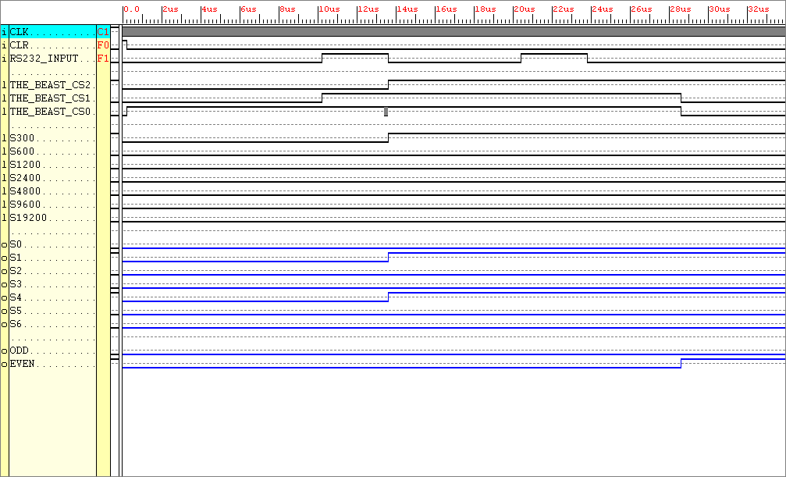

Shown next to the timing diagram is the complete ASM chart, this allows direct verification of the actual response
(i.e. the waveform generated by the circuit) against the behaviour specified in the ASM chart.
Because of the resolution required to show the whole set of simulation results, not all the state transitions are possible to visualise.

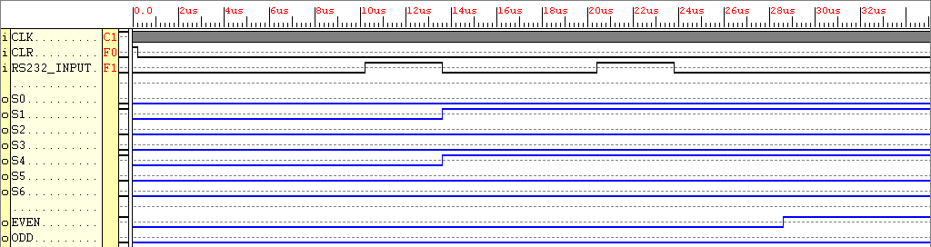

Figure 2.18 Simulation Results, RS232_Input moving at 300 Baud with an even parity sample bit

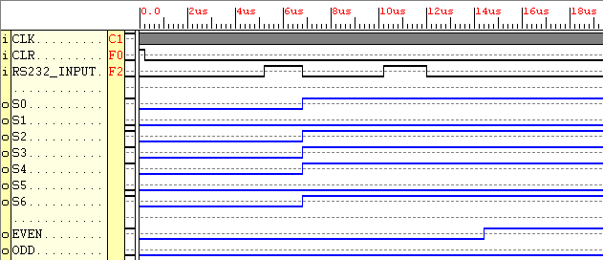

Figure 2.19 Simulation Results, RS232_Input moving at 600 Baud with an even parity sample bit

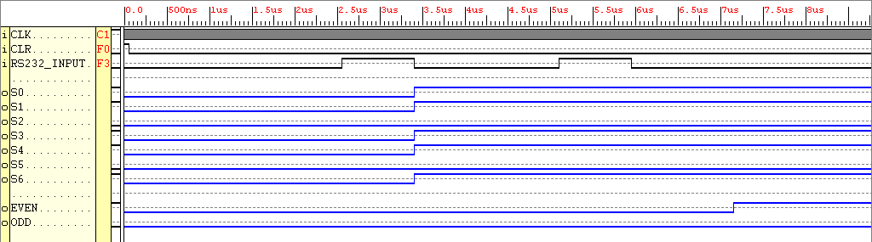

Figure 2.20 Simulation Results, RS232_Input moving at 1200 Baud with an even parity sample bit

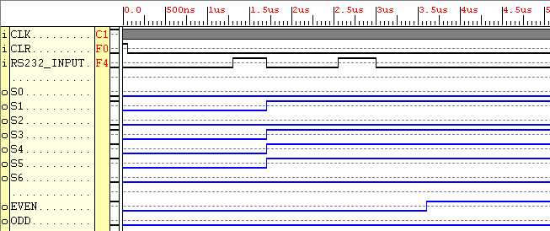

Figure 2.21 Simulation Results, RS232_Input moving at 2400 Baud with an even parity sample bit

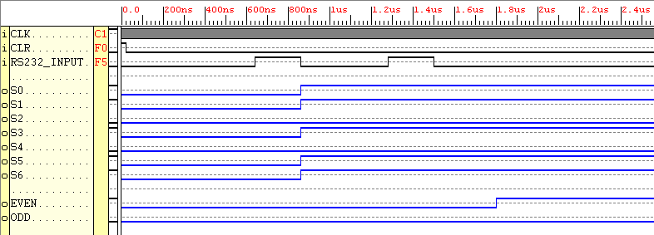

Figure 2.22 Simulation Results, RS232_Input moving at 4800 Baud with an even parity sample bit

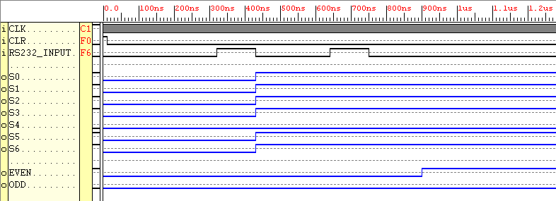

Figure 2.23 Simulation Results, RS232_Input moving at 9600 Baud with an even parity sample bit

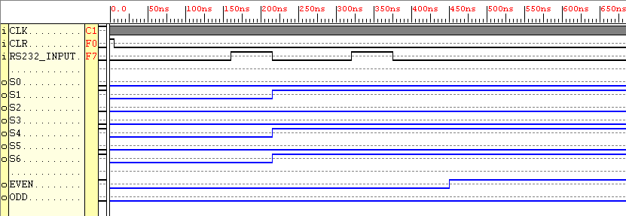

Figure 2.24 Simulation Results, RS232_Input moving at 19200 Baud with an even parity sample bit

Looking at Figures 2.12 – 2.19, their results have one thing in common, they show the incoming data RS232_INPUT has an even parity bit. As was shown in PART 1 of this report, a transition in RS232_INPUT from 0 > 1 then 1 > 0 causes the baud rate of the system to be outputted i.e. hence a change in S0 – S6 occurs. The system knowing the baud rate, waits 4 and a half periods, then samples the parity bit. The system is left in a state of limbo until the system is RESET.

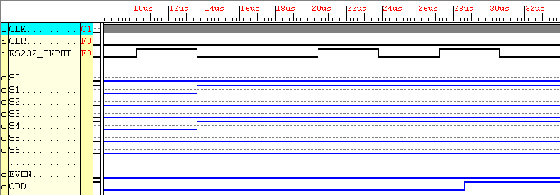

Figure 2.25 Simulation Results, RS232_Input moving at 300 Baud with an odd parity sample bit

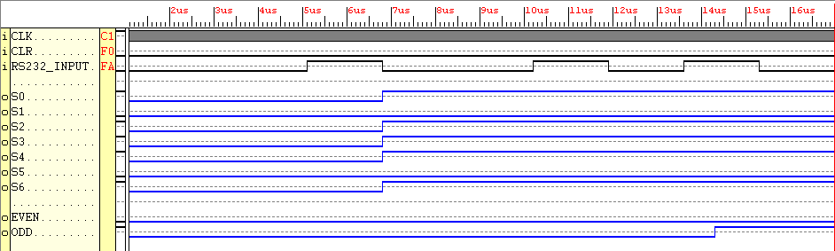

Figure 2.26 Simulation Results, RS232_Input moving at 600 Baud with an odd parity sample bit

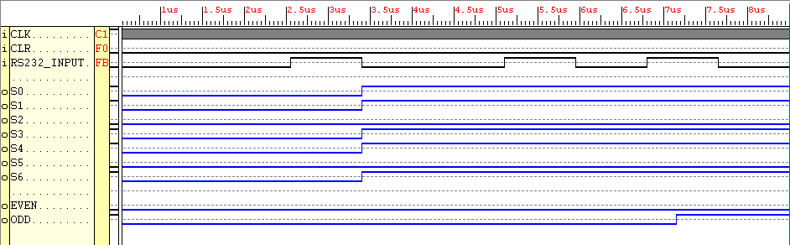

Figure 2.27 Simulation Results, RS232_Input moving at 1200 Baud with an odd parity sample bit

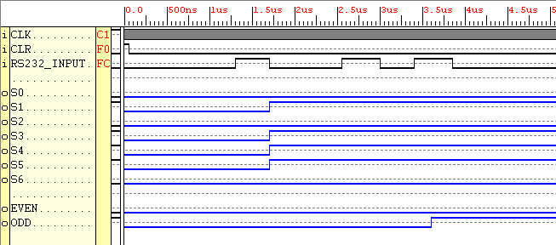

Figure 2.28 Simulation Results, RS232_Input moving at 2400 Baud with an odd parity sample bit

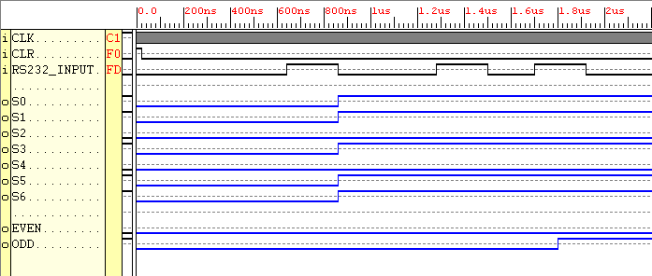

Figure 2.29 Simulation Results, RS232_Input moving at 4800 Baud with an odd parity sample bit

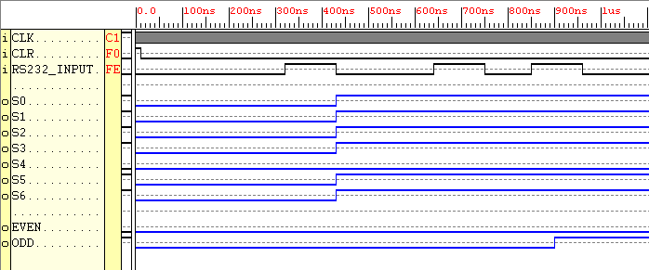

Figure 2.30 Simulation Results, RS232_Input moving at 9600 Baud with an odd parity sample bit

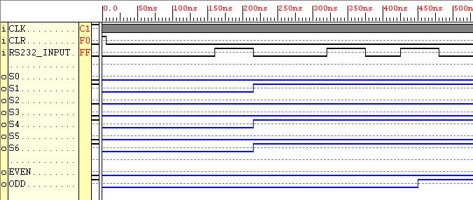

Figure 2.31 Simulation Results, RS232_Input moving at 19200 Baud with an odd parity sample bit

Looking at Figures 2.12 – 2.19, their results have one thing in common, they show the incoming data RS232_INPUT has an odd parity bit. As was shown in PART 1 of this report, a transition in RS232_INPUT from 0 > 1 then 1 > 0 causes the baud rate of the system to be outputted i.e. hence a change in S0 – S6 occurs. The system knowing the baud rate, waits 4 and a half periods, then samples the parity bit. The system is left in a state of limbo until the system is RESET.

The RS232 monitor works correctly in accordance with it’s simulation results, however only until it’s implemented into an FPGA is it known function correctly. So far a synthesised working model has been achieved, the next step is to assign the inputs and outputs of the XS40 board in accordance with the inputs and outputs observed on the simulation results. Hence through a program called the constraints editor, pins are assigned to the real tested signals.

2.4.1 Implementing the Design into Hardware

Shown below is a table of constraints listed for use with the target Xilinx FPGA, which is found on the XS40 design board.

Signal | Pin Assignment
CLK | P29
CLR | P4
EVEN | P80
ODD | P82
RS232_INPUT | P3
S0 | P25
S1 | P26
S2 | P24
S3 | P20
S4 | P23
S5 | P18
S6 | P19

Figure 2.32 Constraints editor pin assignments

After assigning the correct pins to the correct signals, the constraints editor file was saved as with a UCF extension (user constraints file) and updated. The synthesised model in XNF (Xilinx netlist file) format was implemented along with the updated user constraints file. The design when through the place and route process this produced a BIT file which then could be loaded into the XC4000XL PC84 FPGA using the XSLOAD program. The testing procedure used can be found in the Appendix of this report.

Appendices

